Add cover Add comment

**Elements To Successful Swing Trading**

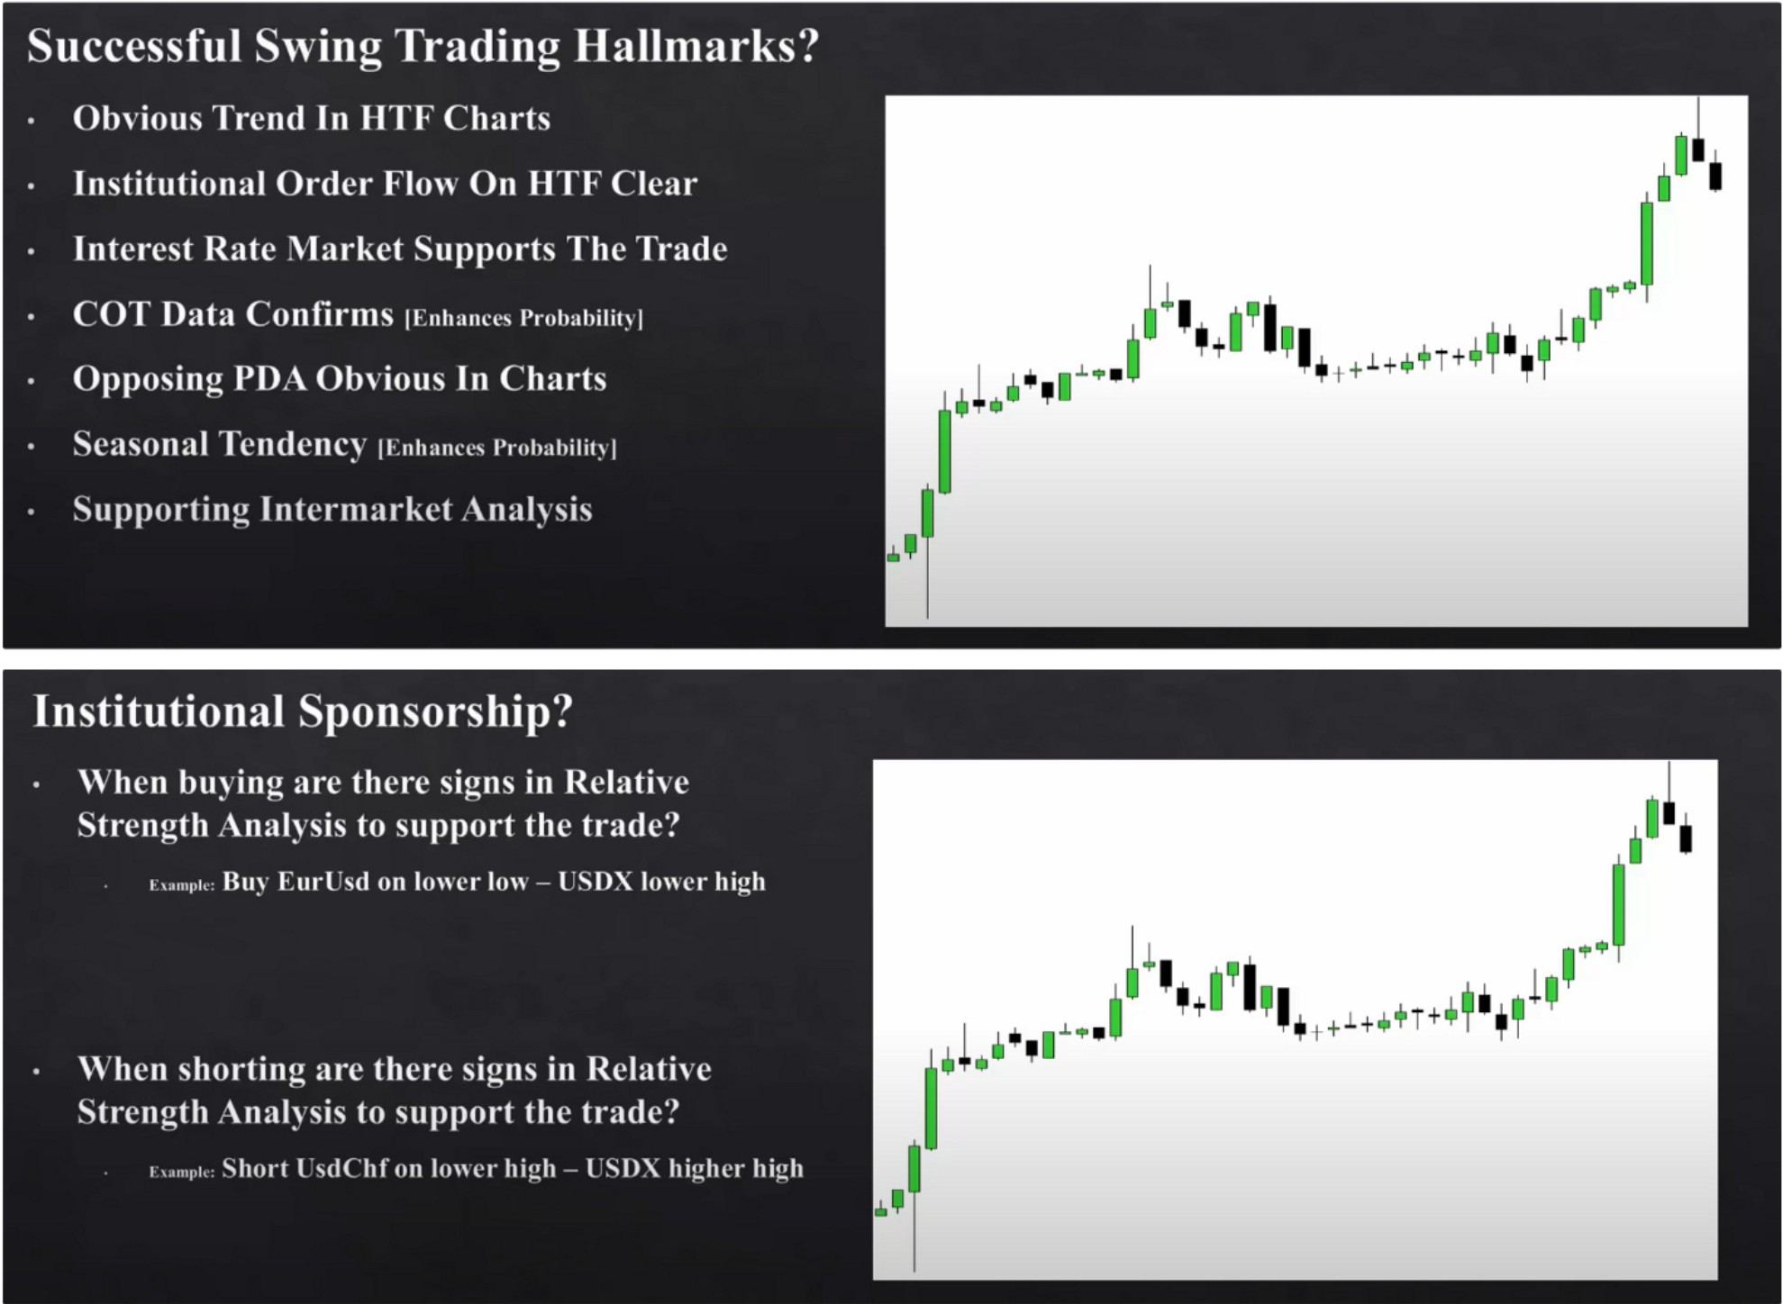

SMT divergences to back up institutional sponsorship

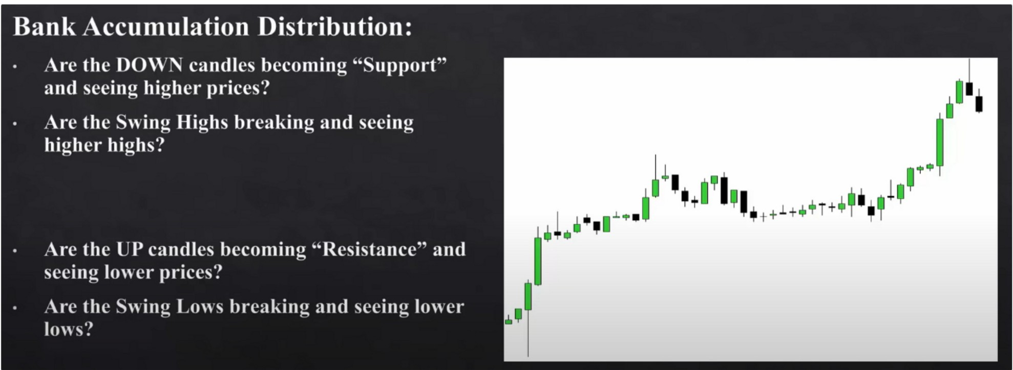

The way we look at accumulation is that we look at the downcandles because they should support buying

The more obvious a PD array is the better the trade will be

If price comes out of a consolidation, then look for it to move to a premium buyside imbalance, or discount sellside imbalance

The most obvious and cleanest price action is the highest probability, its where you dont need to force the idea. Its going to be the easiest once as well, because its easy to see, if you have to convince yourself then its likely not a good trade

Institutional levels are the mid figure levels the big rounded levels

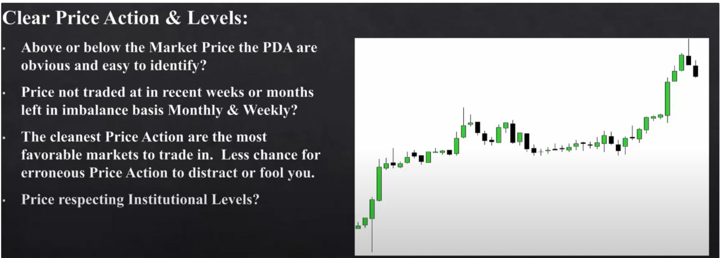

Every model has to have rule based conceptual methods

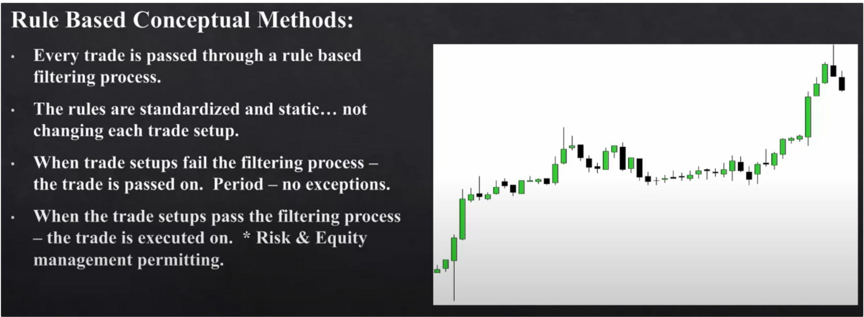

If you see a better setup somewhere then you have to cut the trade youre currently in, or take something off. But dont stay in the trade fully.

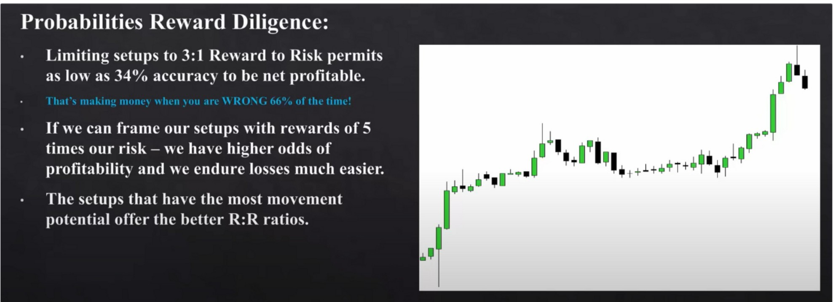

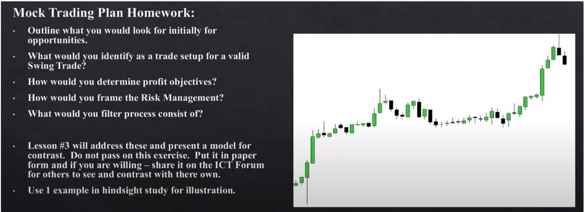

Know what youre looking for and then frame if its a valid swing trade Do the homework, it will help you

Also have the idea of what kills the trade, why do you not take the trade anymore? You want to have everything outlined, you want to have rules around everything so no emotions can get involved.

Arjo I Twitter, lnstagram I Linktree

Linktree. Make your link do more.

, https://t.co/HhmmTN1fUI

JavaScript is not available.

https://twitter.com/arjoio